The Four Corner Index (FCI)
A Fast Lookup Method for Chinese Characters

Source: 新华字典〔1971年修订重排本〕商务印书馆，北京 1976年

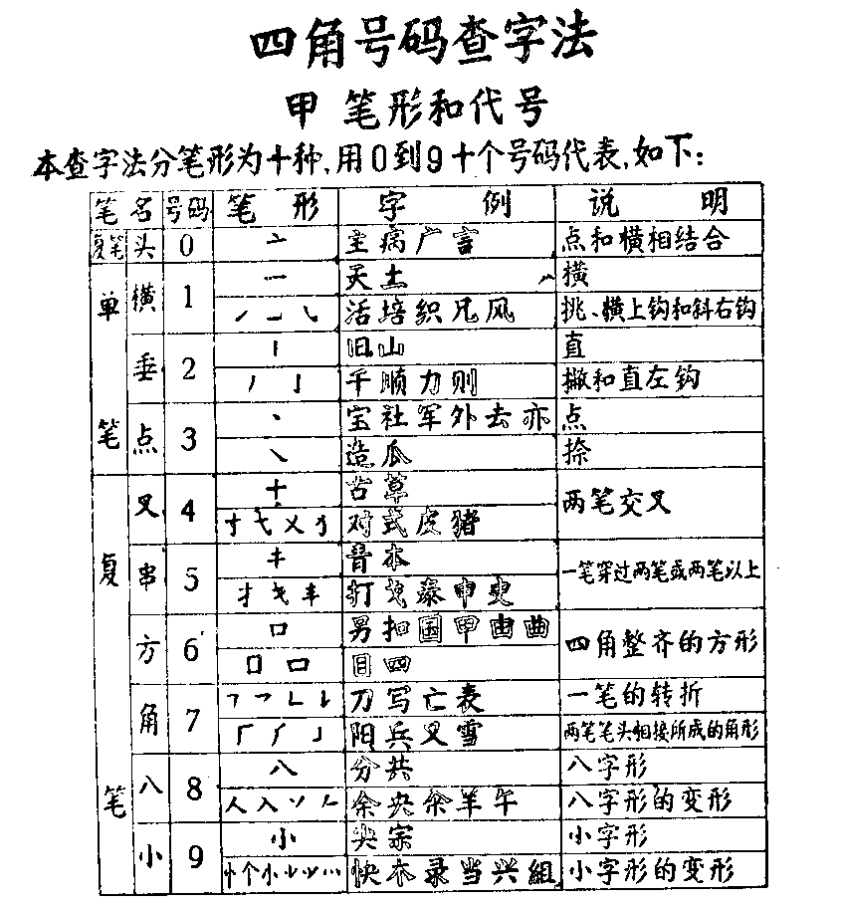

(i) Stroke categories and associated numbers

The Four Corner Index defines 10 categories of strokes and associates a unique number with each of these categories. Sample characters for each category are shown in the above table, in the second column from the right.

No. / Description
0 = "Top" (头tou2): dot & horizontal stroke compound.
1 = "Horizontal" (横heng2): also any stroke slanting up ↗ (挑tiao3), any horizontal stroke with upward hook, or any stroke slanting down to the right ↘ with upward hook (斜xie2).
2 = "Vertical" (垂chui2): also any stroke slanting down to the left ↙ (撇pie4), and any vertical stroke with leftbound hook.
3 = "Dot" (点dian3): also any stroke slanting down to the right ↘ [without hook] (捺na4).
4 = "Cross" (叉cha1): two crossing strokes.
5 = "String" (串chuan4): a vertical stroke or a stroke slanting down to the right ↘ that crosses two or more other strokes.
6 = "Rectangle" (方fang1): strokes forming a rectangle.
7 = "Corner" (角jiao3): a "broken" single stroke (折zhe2), or two strokes joining their ends to form a corner.
8 = "Eight” (八ba1): two strokes shaped like Chinese character 八, or similar two-stroke compounds.
9 = "Small” (小xiao3): three strokes shaped like Chinese character 小, or similar three-stroke compounds.

NB. 1, 2, and 3 are simple strokes, while 0, 4, 5, 6, 7, 8, and 9 are compounded strokes.

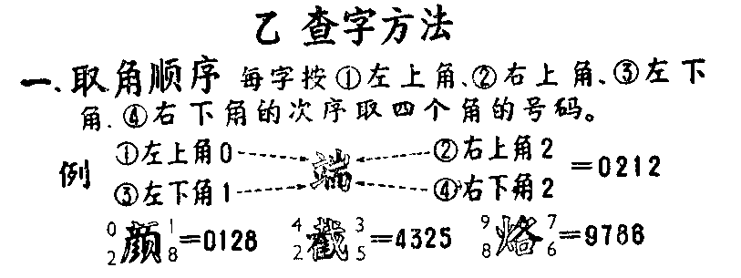

(ii) How to look up a Chinese character

1. Numbering sequence

Strokes appearing in each of the four corners of a Chinese character are given numbers as per the description above. The numbering sequence is: (1) upper lefthand corner, (2) upper righthand corner, (3) lower lefthand corner, and (4) lower righthand corner. See sample characters above.

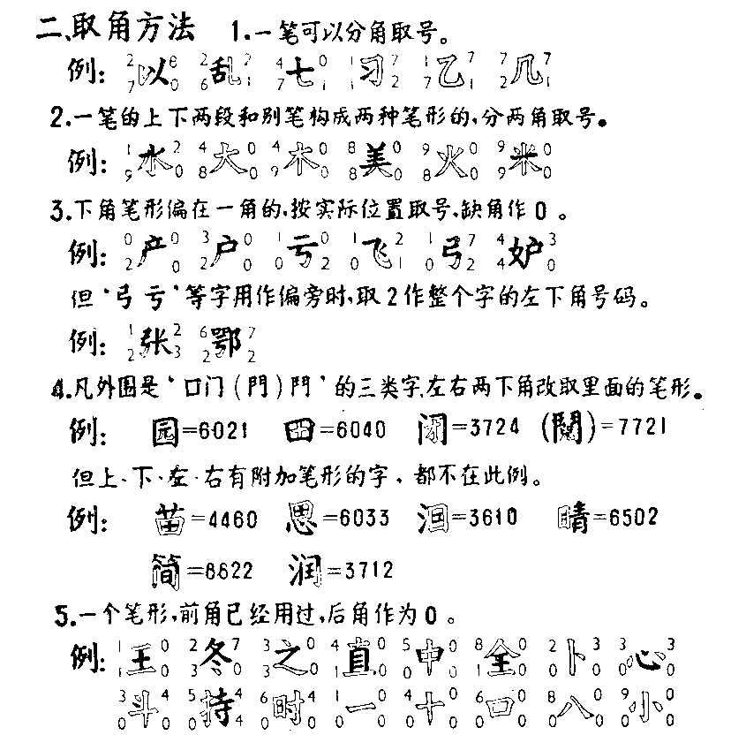

2. Numbering rules

2.1. A stroke generates multiple numbers when it reaches another corner and changes its shape.

2.2. A stroke whose upper or lower portion joins with another stroke to form a compounded stroke in another corner generates multiple numbers accordingly.

2.3. When a stroke in the lower part of a character slants towards one corner, it generates a number for this corner; the other (empty) corner is numbered 0.

However, when 弓,亏,etc. are on the left side (旁pang2) of a character, the lower lefthand corner is numbered 2.

2.4. When a character contains one of the outer enclosures 囗, 门 (門), or 鬥, the lower lefthand and righthand corners are numbered according to the strokes inside the enclosure.

The above rule does not apply when other strokes are added on the outside of an enclosure.

2.5. When a stroke that has already generated a number for a previous corner reaches another corner without changing its shape, this corner is numbered 0.

See sample characters above for each of these rules.
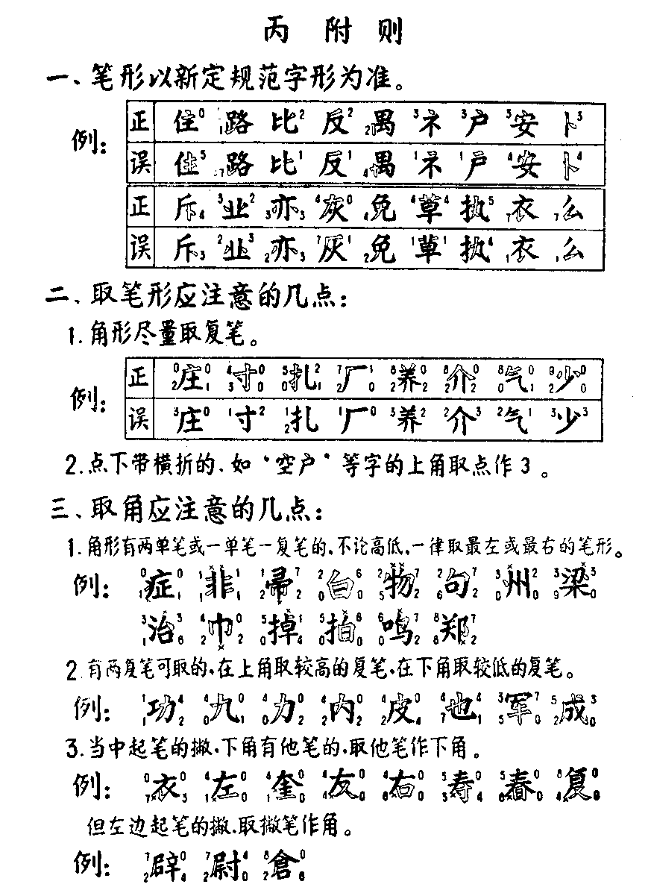

(iii) Special rules

1. Stroke shapes follow the standards for Chinese characters promulgated in the PRC, e.g.:

2. When determining stroke and compound numbers, the following rules should be observed:

2.1. When strokes can be combined to form compounds (as given in the initial table), such compounds are used for numbering, e.g.:

2.2. A comma-shaped stroke does not form a ‘0’ compound with a hooked horizontal stroke such as in ¿Õ or »§; in such cases, the upper corner is numbered 3.

3. When determining which strokes or compounds belongs to each corner, the following rules should be observed:

3.1. When a choice must be made between two single strokes or a single stroke and a compound, independent of its vertical position, priority is given to the stroke or compound at the extreme left or right, e.g.:

*) This 2 stands for the hooked vertical stroke at the extreme right

3.2. When a choice must be made between two compounds for the upper corners, priority is given to the compound that ascends higher vertically, while for the lower corners, priority is given to the compound that descends lower, e.g.:

3.3. When a left-bound stroke leading diagonally downward proceeds towards the center and another stroke or compound occurs in the lower half of the character, the latter will be used for numbering the lower corner(s), e.g.:

This rule does not apply when a left-bound stroke leading diagonally downward is entirely on the left side of a character; in such case, this stroke is used for numbering, e.g.:

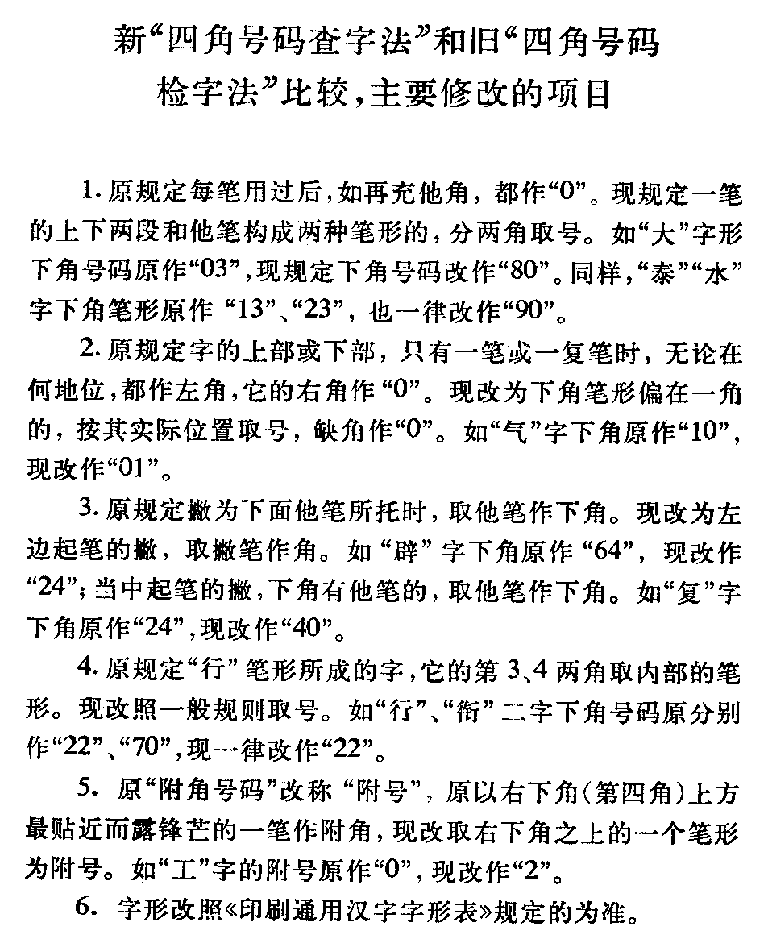

新 "四角号码查字法” 和旧 "四角号码
查字法” 比较，主要修改的项目

1. 原规定每笔用过后，如再充他角，都作 "0”。 现规定一笔的上下两端和他笔构成两种笔形的，分两角取号。
如 "大” 字形下角号码原作 "03”，现规定下角号码改作 "80”。同样，"泰” "水” 字下角笔形原作"13”、"23”，也一律
改作 "90”。
2. 原规定字的上部或下部，只有一笔或一复笔时，无论在何地位，都作左角，它的右角作 "0”。
现改为下角笔形偏在一角的，按其实际位置取号，缺角作 "0”。如 "气” 字下角原作 "10”，现改作 "01”。
3. 原规定撇为下面他笔所托时，取他笔作下角。现改为左边起笔的撇，取撇笔作角。如 "辟” 字下角原作"64”， 现改作 "24”；当中起笔的撇，下角有他笔的，取他笔作下角。如 "复” 字下角原作 "24”，现改作 "40”。
4. 原规定 "行” 笔形所成的字，它的第 3、4 两角取内部的笔形。现改照一般规则取号。如 "行”、"衔” 二字下角
号码原分别作 "22”、"70”，现一律改作 "22”。
5. 原 "附角号码” 改称 "附号” ，原以左下角(第四角)上方最贴近而露锋芒的一笔作附角，现改取左下角之上的
一个笔形为附号。如 "工” 字的附号原作 "0”，现改作 "2”。
6. 字形改照《印刷通用汉字字形表》规定的为准。

